Model 1 (Basic Statistics):
- Ensemble (using other tiny models)

Model 2 (Sentiment Analysis):
- Learn how to scrape data / info from social media (X, reddit, instagram)

Notes:
Starters: The five starters from both the Eastern and Western conferences are selected by a combination of votes:

Fans: account for 50% of the vote.
Current NBA Players: account for 25% of the vote.
Media Panel: accounts for the remaining 25% of the vote.

For 2026, the starters will be selected without regard to player position.
Reserves: The seven reserve players from each conference are selected solely by a vote of the NBA head coaches.

Meeting (11/19, 2025):
Model 1:
- Decide what statistics should our model take in
  - Points per game / Team record / Rebounds / Assist/ +/- /
Kaggle DataSet:
https://www.kaggle.com/datasets/vivovinco/2023-2024-nba-player-stats/data
https://www.kaggle.com/datasets/vivovinco/20222023-nba-player-stats-regular
- See LeagueDashPlayer below

Model 2:
- Learn how to scrape data

import requests

url = "https://books.google.com/ngrams/json"
params = {
"content": "computer",
"year_start": 1900,
"year_end": 2008,
"corpus": 15,
"smoothing": 3
}

res = requests.get(url, params=params)
print(res.json())

from nba_api.stats.endpoints import LeagueDashPlayerStats

ldr = LeagueDashPlayerStats(
season='2025-26',
season_type_all_star='Regular Season',
measure_type_detailed_defense='Base',
per_mode_detailed='PerGame',
last_n_games=10
)
df = ldr.get_data_frames()[0]
df.head()

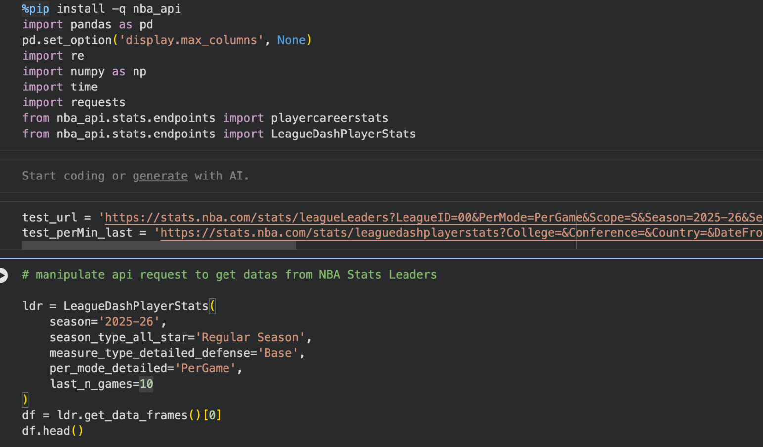
Sentiment Analysis
https://dl.acm.org/doi/fullHtml/10.1145/3501774.3501796
The goal of this final project assignment is to present original work in applying machine learning paradigms from class to a dataset with a compelling real-world application. While the machine learning competition was designed to sharpen your model optimization skills, this project should have a broader scope in which you explain the real-world context that could benefit from your machine learning approach. Think back to the introduction lecture where we discussed who the stakeholder or consumer would be for each scenario.
The final project must be completed in groups of 3 to 7 members. You may mix-and-match between DATA 144 and EDUC 244 students, but only EDUC 244 students will be responsible for contributing to the 244-only Final Project Paper assignment. Any groups with more than 7 members will incur a 20% penalty per person. Any groups with fewer members will not be permitted to present due to a lack of available presentation spots. The effort expected from each group member is approximately equivalent to the effort required for two labs. Consequently, there will be higher expectations for larger groups.

Sources of Datasets
- UCI ML repository
- Links to an external site.

- Kaggle
- Links to an external site.

- Open ML
- Links to an external site.

- Stanford Large Network Datasets
- Links to an external site.
- (snap)

Submission Details
The submission of the final project presentation will occur by two parts. EDUC 244 students must also complete a Final Project Paper, which they can read more about here. All assignments are due strictly by December 2nd, 11:59pm, with no alternate due date. All assignments that are submitted 0-12 hours late will incur a 10% penalty, and anything thereafter, a 20% penalty. Read about the submissions below:
- FP Presentation (.pdf): Please submit a PDF of your slide deck to this Gradescope assignment, naming your slide deck fileFinal Project Report (EDUC 244 only) based on your sign-up day, session number, and project title (e.g., "day1_session1_ebike_distribution_improvement").
- FP Code (.ipynb/.zip): Please submit your .ipynb, .csv, and other code file(s) to this assignment. If you have multiple code files, which is very likely, please submit them as a .zip file.

Presentation Details
The following are suggested sections of an effective presentation.
- Introduction: Describe your research question(s) and discuss the project context and motivation (who are the stakeholder(s) and what are the benefits to them?)
- Dataset: Describe the raw dataset: where or how did you collect it, descriptives, feature engineering, filtering, etc.
- Methods: Describe the machine learning methods you used to approach the problem at hand. You may use algorithms that we did not cover in class, but please give some background info if you do.
- Results and Conclusions: Synthesize individual work and provide findings and conclusions. Do not forget to mention the implications of your project and its results. Would you say it's ready to be used in the real-world yet? If not, what needs to be solved before you would say it was ready?

Grading
- Quality of Presented Materials – 3pts
  - Includes quality of slides/images/props/articulation of techniques
- Teamwork – 4pts
  - Expect to receive full scores in this category unless your presentation exhibits a clear lack of continuity between different member's slides. Though solo groups should not exist, solo submissions will automatically get a 0 for this item.
- Quality of Organization – 6pts
  - How well the idea was communicated and how well the presentation was organized, i.e. how well the presentation flowed from one slide (and presenter) to another.
- Problem and Approach – 9pts
  - How interesting the problem posed was and how rationally, creatively, and appropriately concepts were applied from the class.
- Results – 3pts
  - How successful was the project?
- Presentation Proposal – 2pts, graded in respective assignment
  - See Final Project Presentation Proposal assignment
- Presentation Attendance – 3pts, graded in respective assignment
  - See Final Project Presentation Attendance assignment [link to be added at a later date]

Expectations
Every member is expected to present for at least two minutes. Every group, regardless of the number of members, should present for 15 minutes plus 3 minutes for questions. All group members will receive the same grade for the final presentation. While the same rubric will be used to assess both DATA 144 and EDUC 244 students, the presentation will count for 100% of the DATA 144's final project grade and 30% of the EDUC 244's final project grade (the other 70% being the paper).
Due to the size of the class and limited days to present, smaller groups will not be allowed. You may use a private dataset so long as that dataset can be shared with your group members. It is not sufficient for your final project to simply copy a Kaggle competition prediction task.

